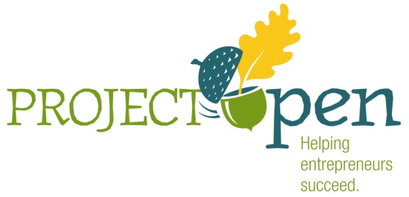
Intake Application

Project OPEN provides entrepreneurial education and business support to entrepreneurs who already own or want to start a business in Saline County, Kansas.

Name: _____________________________________________ Date: ___________________

Mailing Address: _____________________________________________________________

Phone: ______________________________ Cell: __________________________________

E-Mail: _____________________________________________________________________

If you have an existing business or have a business name please provide the following:

Business Name: ______________________________________________________________

Address: ____________________________________________________________________

Phone: _________________________________ Fax: ________________________________

Date business opened: _________________________________________________________

Please describe the Business – product or service that you plan on or are providing or selling to the public: ____________________________________________________________________________________________________________________________________________________________________________________________________________________________________________________________________________________________________________________________________________________________________________________________________________________________________________________________________________________________________________________________________________________________________________________________________________________________________________________________________________________________________________
How Project OPEN works:
Applicants must reside in Saline County or own a business in Saline County Kansas. Project OPEN includes Entrepreneur Training and Business Development Services. Applicants must successfully complete this intake application, have a personal interview with designated Project OPEN intake staff, help design an appropriate assistance plan and write or update their business plan prior to qualifying for funding.

Entrepreneur Training is available through the Kansas Small Business Development Center (KSBDC) these fee based courses focus on best business practices and business plan development. The course fees may be partially reimbursable by Project Open upon satisfactory completion. Based upon their intake assessment and assistance plan, applicants may be required to attend one or more of these classes as part of their assistance plan prior to applying for funds.

Business Development Services include competitive grants/loans, mentoring support and/or service referral. Entrepreneurs who successfully complete the assistance plan and write a business plan will be eligible to apply for one time expansion or startup funding. Level of available funds may vary according to current available Project OPEN funds. Funds may be awarded as a grant, a loan or a combination of a grant and a loan. Applications are accepted quarterly during the posted application period. Applications for funding will not be accepted outside the posted application period. These funds are on a first come basis and are awarded through a competitive selection process as evaluated during the quarter in which the application is submitted. The decision to award the funds rests solely with the Project OPEN Financial Review Board. If you are awarded funds, Project OPEN will monitor your project to assure that the awarded funds are used as you have stated in your business plan. Project OPEN extends further support by providing participants with a network of experienced, successful business mentors.

PROCESS:
Fill out the initial intake application form and submit it to Project OPEN, P O Box 586 Salina, KS 67402-0586 or deliver to 120 W. Ash Street Salina, Kansas. On line applications are posted at www.projectOPENsalina.com and www.salinadowntown.com and www.salinakansas.org

A Project OPEN team will review your intake application and contact you to schedule a time for a personal interview. The discussion will help clarify where you are with regard to your goals, established business development strategies and development of a business plan as well as determine which service options will be most beneficial to you. By signing an agreement to follow the mutually agreed upon assistance plan, you will be eligible for Project OPEN Services.
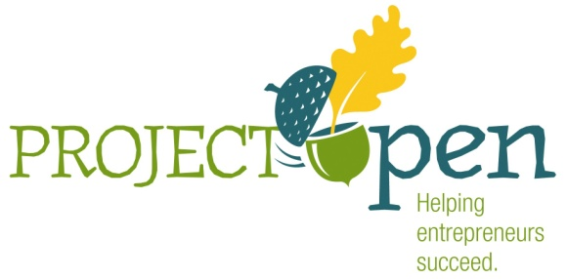
PO Box 586
Salina, KS 67402-0586
785-827-9301
www.projectopensalina.com

